**Assignment 1**

**Deadline for submission on Blackboard: 11/11/2023**

**Q1.** Create a worksheet named ***Summary.*** In this worksheet, create the following Table.

|  |  |  |  |
| --- | --- | --- | --- |
| **Order** | **Application Name (Apps)** | **Revenue** | **Budget** |
| 01 | GG | $ 11,649 | $ 10,593 |
| 02 | Fa | $ 7,718 | $ 6,400 |
| 03 | Blend | $ 15,033 | $ 12,700 |
| 04 | Accord | $ 18,701 | $ 19,100 |
| 05 | Misty Wash | $ 14,432 | $ 15,100 |
| 06 | Whsapp | $ 17,990 | $ 18,008 |
| 07 | Zal | $ 11,022 | $ 13,112 |
| 08 | Mess | $ 17,760 | $ 16,854 |
| 09 | Vivo | $ 30,400 | $ 30,327 |
| 10 | Ymi | $ 20,400 | $ 18,444 |

Then, do as follows:

1. Create additional column with header called **Revenue Analysis**. Fill the value in this column as follows:

* Revenue $≤$ 15000: take the corresponding value of Revenue
* $15,000<$ Revenue $<20,000$: Good
* Revenue $≥$ 20,000: Exceptional

1. Create additional column with header called **Threshold Value**. Fill in this column by the following equation

$$Threshold Value=\frac{Revenue}{Budget}-1$$

where $Threshold Value$ is shown in the format of percentage (%)

1. Use conditional formatting to highlight any threshold value (%) which is negative value. Also use the same method to highlight any information related to Whsapp (including **Revenue**, **Budget**, **Revenue analysis**)
2. Create additional table as follows

|  |  |  |  |
| --- | --- | --- | --- |
| Largest threshold | Smallest budget | Number of Good in Revenue Analysis | No of both “good” in Revenue Analysis which has budget less than 15000 |
|  |  |  |  |

Known that, in this table, Largest threshold and Smallest budget are filled up by using VLOOKUP. COUNTIF and COUNTIFS can be used to calculate the values of remaining columns.

1. Use the line chart with full format to display **Revenue**, **Budget**, and **Threshold Value.**

**Q2.**

Create the following table in a worksheet named as ***Book price***

|  |  |  |  |  |  |  |
| --- | --- | --- | --- | --- | --- | --- |
| Month | January | February | March | April | May | June |
| Average Salary of Employees | $ 1,500 | $ 1,500 | $ 1,600 | $ 1,800 | $ 1,900 | $ 2,100 |
| Books sold | $ 2,000 | $ 1,600 | $ 4,000 | $ 3,000 | $ 2,300 | $ 5,000 |

**Table 3**

1. Create another row called **Profit** which is calculated by

**Profit=Books sold- Average Salary of Employees**

Perform the calculation of **Profit** for each month, January to June.

1. Create a standard chart that can show the comparison of 3 data sets **Average Salary of Employees**, **Books sold**, and **Profit**.
2. Create a Pivot Table in another spreadsheet named **Sum** based on data given in Table as follows

|  |  |  |  |  |  |  |
| --- | --- | --- | --- | --- | --- | --- |
|  | **Sum of January** | **Sum of February** | **Sum of March** | **Sum of April** | **Sum of May** | **Sum of June** |
| Average Salary of Employee | $ 1,500 | $ 1,500 | $ 1,600 | $ 1,800 | $ 1,900 | $ 2,100 |
| Books sold | $ 2,000 | $ 1,600 | $ 4,000 | $ 3,000 | $ 2,300 | $ 5,000 |
| **Grand Total** | **$ 3,500** | **$ 3,100** | **$ 5,600** | **$ 4,800** | **$ 4,200** | **$ 7,100** |

and then in the same spreadsheet, create a Pivot Chart based on the obtained Pivot Table as follows

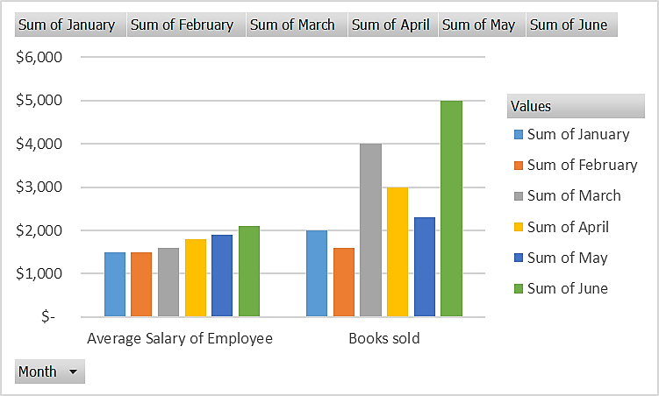

1. Use appropriate chart to obtain the exact linear equation describing the future estimates of **Profit** in the later 6 months, from July to December. Show clearly on the chart the obtained equation.